**Geobiology 2019 Conference Guide**

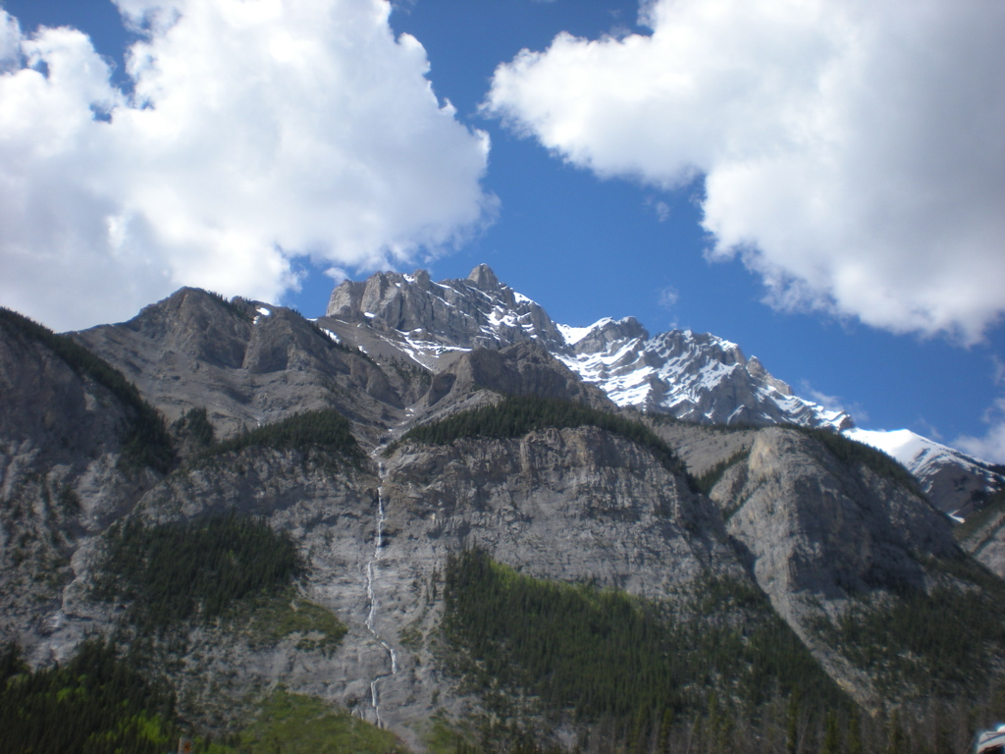

Table of Contents

Welcome 2

General Information 2

Conference Schedule 3

Map of the Banff Centre 6

Map of Banff 7

Organized Field Trips 8

Social Activities 9

Historic and Tourist Sites 9

Hiking 9

Gear Rentals 10

Restaurants 11

Shopping 13

Amenities and Attractions 13

Hotels and Campgrounds 14

Rental Cars 15

Airport Shuttle 16

# Welcome

Thank you for joining us in Banff, Alberta for Geobiology 2019 – the 2nd Geobiology Society Conference! Banff provides us with a world-class, and picturesque venue for the meeting. The conference is being held at the Banff Centre for the Arts, situated on the side of Tunnel Mountain, overlooking the Bow Valley.

At this innovative conference emphasis is placed on the work of early career scientists, with talks delivered by senior post-doctoral researchers or junior faculty members. On Monday and Tuesday evening, graduate students and postdoctoral scholars present posters; to maximize the opportunity to share your work and interact with other attendees, posters will be left up for both poster sessions.

One of the advantages of hosting Geobioloy 2019 in Banff, is that it is a tremendous venue for those who wish to bring their families! Surrounded by the beautiful Canadian Rocky Mountains there are many opportunities for hiking, biking, outdoor adventures, and even shopping or relaxing. Banff is a welcoming town, with a tremendous reputation for year-round adventure.

Thanks for making the trip out, and welcome!

# General Information

General information on the conference, the Banff Centre for the Arts, Banff and other national parks nearby can be found at the following websites:

Geobiology 2019:

https://cms.eas.ualberta.ca/geobiology2019/

The Banff Centre for the Arts:

<https://www.banffcentre.ca>

Banff Tourism:

<https://www.banfflakelouise.com>

or

<https://www.travelalberta.com/ca/places-to-go/canadian-rockies/banff/>

Banff National Park

<http://www.pc.gc.ca/eng/pn-np/ab/banff/index.aspx>

Yoho National Park

<http://www.pc.gc.ca/eng/pn-np/bc/yoho/index.aspx>

Jasper National Park

<http://www.pc.gc.ca/eng/pn-np/ab/jasper/index.aspx>

Kootenay National Park

<http://www.pc.gc.ca/eng/pn-np/bc/kootenay/index.aspx>

# Map of the Banff Centre

../../Downloads/Banff%20Centre%20Campus%20Map.pdf

# Map of Banff

**../../Downloads/Visitor%20Map.pdf**

# Organized Field Trips

1. **Pre-conference: Lower Cambrian fossiliferous beds**

One-day field seminar to view sections of the Gog Group and Mount Whyte Formation in the area east of Saskatchewan Crossing along Alberta Hwy 11. The focus of discussion will be the age constraints known for the Gog Group, the significance of bioturbated units within the Gog Group, and overall changes in the sedimentary environment over time. The Mount Whyte Formation, named by Walcott in 2008, is stratigraphically lower than the Stephen Formation. In the field area, the Mount Whyte Formation is distinctive for its’ heavily bioturbated silty shales that are locally very well displayed.

The field seminar will focus on a discussion of analytical techniques that could be used to better understand the studied units. Since this field trip will be outside the national parks, participants will be invited to sample lithologies that are of interest. Given outcrop access, the fieldtrip will be limited to 24 participants. The trip will leave from **the front of the Professional Development Center at 8:00 AM on Sunday June 9th** and return to Banff by approximately 5:00 PM, 2 hours before the icebreaker. For those confirmed as attending please arrive in Banff by Saturday June 8th. The cost will be $75/person (including transportation and lunch).

1. **Post-conference (Mt. Stephen Fossil Beds) – 20 spots maximum:**

Made famous by the early exploration and collection of fossils by Charles Doolittle Walcott, the Walcott quarry sits on the shoulder of Mt. Walcott in Yoho National Park. Across the valley from the Burgess Shale, lies the Mt. Stephen fossil beds - an excellent collection of Cambrian trace and body fossils, most notable for its well-preserved trilobites. Neither of these localities are accessible without escort by a licensed guide, as they are protected UNESCO world heritage sites. We have now arranged with the Burgess Shale Geoscience Foundation a field trip to the Mt. Stephen Fossil Beds (~$120/person, including guided tour, bus and packed lunch) for Thursday June 13th, immediately following the conference. Due to group size restrictions allowed at the sites, we are only able to offer 24 spots, which translates into two separate guided tours of 12 persons maximum. Note: Due to trail conditions (i.e., avalanche hazards, seasonal road closures) access to the Walcott Quarry is not be available until early July.

Both guided tours will leave together from **the front of the Professional Development Center at precisely 7:15 AM on Thursday June 13th** to meet the guides from the Burgess Shale Geoscience Foundation at the visitor center in Yoho National Park by 8:30 AM. The first tour will depart at 8:30 AM and the second tour will depart at 9:00 AM. Both tours will return to Banff by approximately 5:00 PM.

For more information on the Burgess Shale and Mt. Stephen Fossil Bed Hikes see:

[http://www.pc.qc.ca/eng/pn-np/bc/yoho/activ/burgess.aspx](http://www.pc.gc.ca/eng/pn-np/bc/yoho/activ/burgess.aspx)

**NOTE: It is illegal to collect fossils within the province of Alberta, or the national parks, and penalties can range from fines up to $50,000 or a year in prison.**

# Social Activities

We have arranged for a welcome ice breaker on Sunday evening at 7:00 pm at the Banff Centre, the following two night, there will be an on-site dinner at 7:00 pm followed by a poster session at 8:00 pm. Beverages will be available at dinner and the poster session. On Wednesday the evening will be free for dinner in Banff and a conference wrap-up party at a location to be determined. At Geobiology 2017 popular evening destinations included Wild Bill’s Saloon and High-Rollers Bowling Alley.

# Historic and Tourist Sites

1. Cave and Basin: the birth place of the Canadian National Parks, and the original hot spring pool in Banff.
2. Banff Upper Hot Springs: the upper hot springs have a pool where you can relax and soak in the hot springs, or book into the spa.
3. Banff Park Museum: a museum on the south end of Banff Ave with exhibitions on the animals, and minerals of the National Parks.
4. Whyte Museum: located on Bear Street this museum is dedicated to the culture of the Rocky Mountains.
5. Lower Bankhead: located along the Lake Minnewanka Scenic Drive, Bankhead is an old coal mining town. Long gone, but not forgotten, the lower Bankhead site still has the foundations of the old town. Take a self-guided walk through the foundations and learn some of Banff’s history.
6. Banff Springs Hotel: one of Banff’s most-luxurious and oldest hotels, the Banff Springs is a member of the Fairmont Chain. With a golf-course, shopping, and dinning on site, this castle-like hotel is an icon of the Rockies.
7. Cascade Gardens: located on the south end of Banff Ave, just across the bridge, these gardens surround the National Parks administration building. A great place for an afternoon stroll.
8. Sulphur Mountain Gondola: the gondola base is located near the upper hot springs, whisks visitors to the top of Sulphur Mountain where there are several viewpoints, and a restaurant at the upper terminal. The upper gondola base can also be accessed by a moderate to difficult hiking trail, and hikers have historically could ride the gondola down for a reduced rate.
9. Mt. Norquay: the closest ski hill to the town of Banff, the hill is accessed by a switch-backing road. In the summer this road offers tremendous views of the Bow Valley, and the Mt. Norquay ski hill offers a base for hiking and a guided via ferrata.

# Hiking

Prime hiking season in Banff, Yoho, and Kootenay National Parks is generally from early July until mid-September. Although in June trails in the valley bottoms may be in excellent condition, alpine trails may be subject to early season conditions. Early season conditions may increase the difficulty of hikes or make trails impassible and can include: snow (and associated avalanche risks), snow melt, mud, and/or recent trail obstructions. Come prepared for potential early season conditions, as well as temperatures that can fluctuate between from near freezing to upwards of 20ºC during the day varying with elevation.

Banff and Lake Louise have numerous phenomenal hikes, some of which can be accessed directly from town or by a short drive. For trail information and conditions in and around Banff and Lake Louise see:

Banff/Lake Louise: <https://www.pc.gc.ca/en/pn-np/ab/banff>

Trail Conditions: <http://www.pc.gc.ca/apps/tcond/cond_e.asp?oPark=100092>

# Gear Rentals

**In Banff:**

**Bactrax Banff Camping Rentals**

Rents: Camping gear, backpacking gear, bikes

225 Bear Street

403-762-8177

<http://www.campingbanff.com/car-camping-rentals-in-banff/>

**Banff Adventures**

Rents: Bikes

211 Bear Street

1-800-644-8888

<http://www.banffadventures.com/Things-To-Do/Summer-Activities>

**The Banff Canoe Club**

Rents: Canoes, kayaks

Corner of Wolf Street and Bow Ave

403-762-5005

<http://banffcanoeclub.com>

**Banff Cycle**

Delivers and picks up bikes

403-985-4848

<http://banffcycle.com>

**Ultimate Sports Banff**

Rents: Bikes

206 Banff Ave

403-762-0547

<http://ultimatebanff.com>

**Outside Banff**:

**Mountain Equipment Co-op (Calgary)**

Rents: some camping and hiking gear; kayaks, canoes, and stand-up paddle boards.

830 – 10th Ave SW, Calgary, Alberta

403-269-2420

<https://www.mec.ca/en/stores/calgary>

Gear Up Mountain Sport and Rentals

1302 Bow Valley Trail, Canmore, Alberta

403-678-1636

<https://www.gearupsport.com/summer-rentals>

# Restaurants

Banff is home to a great number of restaurants, cafés, and bars. Each day coffee and lunch will be provided, and dinner will be provided on Sunday, Monday, and Tuesday. If you are looking for a place for dinner on Wednesday evening, or will be in Banff for a few days on either side of the conference, see a brief list below that highlights some of Banff’s many options. Please note, hours listed are the most general and may vary by day or season.

**\*\*Note: Banff can be quite busy year-round, if headed out with a large group, we recommend trying to secure a reservation (if possible). Hours listed below may change seasonally.\*\***

**On-site:**

**Three Ravens Restaurant & Wine Bar**

Bar open daily 5pm-9 pm

403-762-6300

**Maclab Bistro**

Open daily from 7am to 2am (breakfast, dinning, and snack menu available). Bar service 11pm to 2 am.

403-762-6141

**Downtown**:

**Magpie and Stump**

Open: 11:30am – 2am

203 Caribou Street

403-762-4067

**Banff Ave Brewing Co.**

Open: 11am – 12am

110 Banff Ave, 2nd Floor Clocktower Village mall

403-762-1003

**Park Distillery Restaurant and Bar**

Open: 11am – 10pm

219 Banff Ave

403-762-5114

*Free Distillery Tours daily at 3:30pm

**Elk & Oarsman**

Open: 11am – 11pm

119 Banff Ave, Second Floor above The Ski Hub

403-762-4616

**Saltlik a rare steakhouse**

Open: 11:30am – late

221 Bear Street

403-762-2467

**The Bear Street Tavern**

Open: 11:30 am – late

213, 211 Bear Street

403-762-2021

**The Bison**

Open: 5 pm – late

213, 211 Bear Street

Above the Bear Street Tavern

403-762-5550

**Melissa’s Missteak - Steak House and Restaurant**

Open: 7am-9:30 pm

218 Lynx Street

403-762-5511

**Tooloulou’s**

Open: 7:30am – 9:30pm

204 Caribou Street

403-762-2633

**Coyotes**

Open: 7:30am – 10pm

206 Caribou Street

403-762-3963

**St. James’s Gate Olde Irish Pub**

Open: 11:30 am – 11:30 pm

207 Wolf Street

403-762-9355

**The Grizzly House**

Open: 11:30 am - midnight

207 Banff Ave

403-762-4055

# Shopping

Banff is home to numerous outdoor, souvenir, and high end shops. Ranging from small gift shops along Banff Ave, to high end stores such as Louis Vitton, and Banff institutions such as Monod’s Sportswear.

Many of the shops are located along the main street – Banff Ave, but there is also the Cascade Shopping Centre at the corner of Banff Ave and Wolf Street. Several more shops can be found on Bear Street, which runs parallel to Banff Ave, one street to the west.

# Amenities and Attractions

As a premier tourist destination, Banff has many amenities and attractions, including a number of spas and adventure tourism opportunities. Here we have highlighted a few that may be of interest. For more information, please consult the Banff and Lake Louise tourism ([https://www.banfflakelouise.com).](https://www.banfflakelouise.com/)

**Spas**:

**Willow Stream Spa at Fairmont Banff Springs**

<http://www.fairmont.com/banff-springs/willow-stream/>

**Attractions:**

**Mt. Norquay Via Ferrata and Sightseeing**

<https://banffnorquay.com/summer/>

**Hydra River Guides**

<http://www.raftbanff.com>

**Chinook Rafting**

<http://chinookrafting.com>

**Banff Trail Riders**

<https://horseback.com>

**Brewster Adventures**

<http://www.brewsteradventures.com/summer-trail-rides>

# Hotels and Campgrounds

If you are planning on arriving a few days early or staying a few extra days Banff has many options spanning from very modest (Samesun Hostel) to highly elegant (The RimRock, Banff Springs Hotel). For the best prices, we recommend booking early and checking travel sites such as Expedia.ca.

**Hotels:**

**Samesun Backpacker Lodge**

<http://samesun.com/backpackers-hostels/banff/>

**Inns of Banff**

<http://innsofbanff.com>

**Best Western Plus Siding Lodge 29**

<http://www.bestwesternsiding29.com>

**Banff Inn**

<http://www.banffinn.com>

**Caribou Lodge & Spa**

<http://banffcariboulodge.com>

**Charlton’s Cedar Court**

<http://www.charltonsbanff.com>

**The Rimrock Resort Hotel**

<http://www.rimrockresort.com>

**Fairmont Banff Springs Hotel**

<http://www.fairmont.com/banff-springs>

**Campgrounds:**

**Tunnel Mountain**

~10-15 minute drive from downtown Banff on Tunnel Mountain Road

**Two Jack Main or Two Jack Lakeside**

~15-20 minute drive from downtown Banff, on Lake Minnewanka Scenic Drive

**Johnston Canyon**

~30-35 minute drive from downtown Banff on the Bow Valley Parkway

For more information see:

<https://www.pc.gc.ca/en/pn-np/ab/banff/activ/camping>

# Rental Cars

**In Banff:**

Banff has a limited number of rental cars, but for those interested the following companies below offer rentals in Banff:

**Avis Car Rental**

Corner of Wolf Street and Banff Ave

403-762-3222

[https://www.avis.ca](https://www.avis.ca/car-rental/avisHome/home.ac)

**Enterprise Rent-A-Car**

521 Banff Ave

403-762-2688

[https://www.enterprise.ca](https://www.enterprise.ca/en/home.html)

**Alamo Rent A Car**

Banff Caribou Lodge & Spa, 521 Banff Ave

1-800-992-8923

<https://www.alamo.com/>

**Hertz Banff Springs Hotel**

405 Spray Ave

403-762-2027

[https://www.hertz.ca](https://www.hertz.ca/rentacar/reservation/)

**Calgary Airport (YYC):**

For those arriving at the Calgary International Airport there are several car rental agencies right at the airport including:

**Avis**

[https://www.avis.ca](https://www.avis.ca/car-rental/avisHome/home.ac)

**Budget**

<https://www.budget.ca/en/>

**Dollar Rent A Car**

<https://www.dollar.com>

**Thrifty**

<https://www.thrifty.com>

**Enterprise Rent-A-Car**

<https://www.enterprise.ca>

**Hertz**

<https://www.hertz.ca/>

**National**

<https://www.nationalcar.ca>

**Alamo**

<https://www.alamo.com/>

# Airport Shuttle

For those arriving at Calgary International Airport, a shuttle regularly runs between the airport and Banff. One of the drop-off locations for the Banff Airporter is directly at the Banff Conference Centre.

<https://banffairporter.com>